Home Assignment #Vivek Class

Q.1 Find all possible interpretations of an array of digits

Consider a coding system for alphabets to integers where ‘a’ is represented as 1, ‘b’ as 2, .. ‘z’ as 26. Given an array of digits (1 to 9) as input, write a function that prints all valid interpretations of input array.

Input is a string consisting of following characters : ‘0’ to ‘9’

Examples

Input: {“11”}

Output: ("aa", 'k")

[2 interpretations: aa(1, 1), k(11)]

Input: {“121”}

Output: ("aba", "au", "la")

[3 interpretations: aba(1,2,1), au(1,21), la(12,1)]

Input: {“918”}

Output: {"iah", "ir"}

[2 interpretations: iah(9,1,8), ir(9,18)]

Q.2. Tree Isomorphism Problem

Write a function to detect if two trees are isomorphic. Two trees are called isomorphic if one of them can be obtained from other by a series of flips, i.e. by swapping left and right children of a number of nodes. Any number of nodes at any level can have their children swapped. Two empty trees are isomorphic.

For example, following two trees are isomorphic with following sub-trees flipped: 2 and 3, NULL and 6, 7 and 8.  
[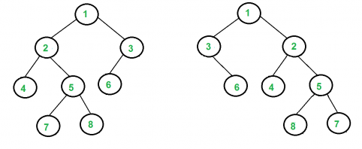](http://d1gjlxt8vb0knt.cloudfront.net/wp-content/uploads/ISomorphicTrees-e1368593305854.png)

Q.3. Boundary Traversal of binary tree

Given a binary tree, print boundary nodes of the binary tree Anti-Clockwise starting from the root. For example, boundary traversal of the following tree is “20 8 4 10 14 25 22″

[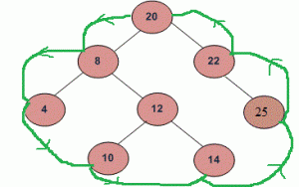](http://d1gjlxt8vb0knt.cloudfront.net/wp-content/uploads/BoundryTraversal.gif)